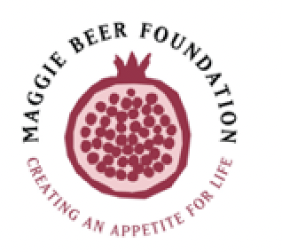
MEDIA RELEASE, Wednesday 21st January 2026

Maggie Beer Foundation launches new training module: Meals with Meaning
Person-centred care for Aboriginal and Torres Strait Islander peoples
The Maggie Beer Foundation (MBF) has launched a new professional development module, Meals with Meaning, designed to support aged care providers in delivering culturally safe, person-centred care for older Aboriginal and Torres Strait Islander peoples.
Meals with Meaning invites aged care staff into ongoing, respectful conversations with residents and their families, recognising the profound cultural, emotional and personal significance of food and mealtimes.
Guided by the principles of person-centred care and cultural safety, the module explores how meals can be created collaboratively to be both nutritionally balanced and culturally meaningful — fostering belonging, dignity and connection.
The module features Maggie Beer alongside leading voices and practitioners, including Lisa Orcher, Cultural Advisor; Shannon Thorne, National Manager, Cultural Strategy at Mission Australia; Steve Brooker, General Manager Aged Care at Mission Australia; Kate Smith, Director of Care at Benjamin Short Grove; and residents at Benjamin Short Grove.
Through real-world examples, community stories and practical guidance, learners are supported to understand how sourcing native ingredients, preparing culturally relevant meals and creating inclusive dining experiences can strengthen trust and wellbeing.
“This module supports aged care providers to move beyond assumptions and into respectful, ongoing conversations with Aboriginal and Torres Strait Islander residents and their families — using food as a powerful point of connection,” says Jane Mussared, CEO Maggie Beer Foundation,
Meals with Meaning is designed for all staff involved in the preparation, service and support of food in aged care homes and has been developed in consultation with experts and peak organisations.
“Cultural safety begins with listening. Food can open the door to stories, identity and connection when care providers approach it with respect and genuine curiosity,” says Cultural Advisor, Lisa Orcher.

Learning outcomes
Participants will learn about:
- The cultural and personal significance of food and mealtimes
- Conducting respectful, strength-based conversations with residents
- How to host culturally inclusive BBQs and shared meals
More than a training resource, Meals with Meaning represents a step towards aged care that truly sees the person — honouring culture, story and community through food.
“Person-centred care is not a policy — it’s a practice. Meals with Meaning gives aged care teams practical tools to deliver care that honours culture and choice every day,” says Steve Brooker, General Manager Aged Care, Mission Australia.
www.maggiebeerfoundation.org.au

About The Maggie Beer Foundation
The Maggie Beer Foundation was established in 2014. We aim to bring about life-altering change to the well-being of older people through access to food full of flavour and nutrients. In collaboration with older people, carers, researchers, foodies, aged care teams and clinicians, we are determined to improve the food experience and, therefore, quality of life for current and future generations of older people and advocate for the central place of good food for older people wherever they live.

For media enquiries, please contact: Melinda Durston, Melting Pot Communications.
M: 0431 934 271
E: melinda@meltingpotcommuncations.com.au

